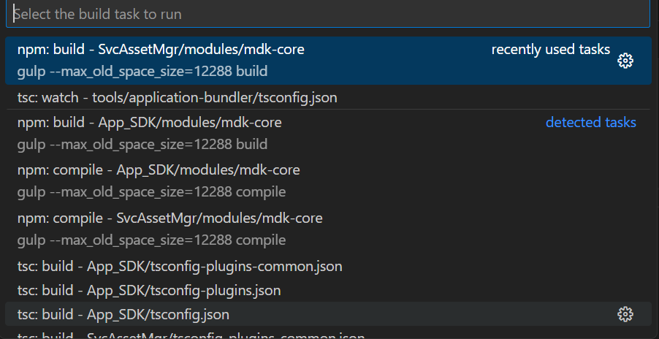

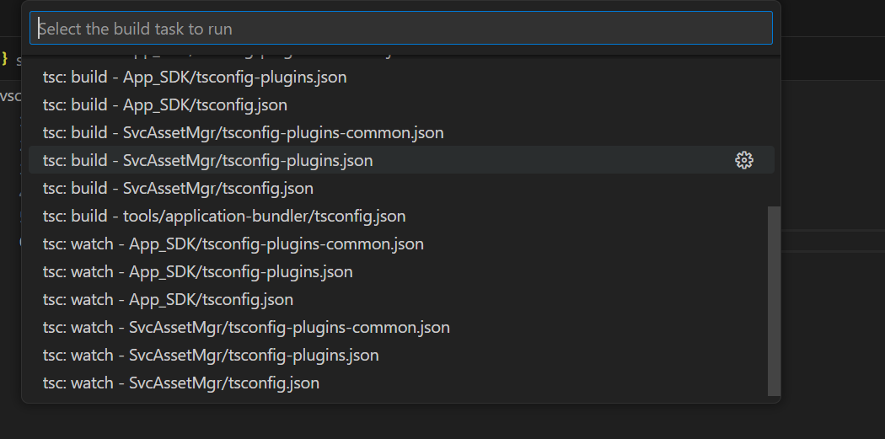

I tried first option below are the logs
* Executing task: npm run build

> mdk-core@6.3.9 build
> gulp --max_old_space_size=12288 build

[08:39:42] Node flags detected: --max_old_space_size=12288
[08:39:42] Respawned to PID: 11556
[08:39:43] No gulpfile found

* The terminal process "C:\WINDOWS\System32\WindowsPowerShell\v1.0\powershell.exe -Command npm run build" terminated with exit code: 1.
* Terminal will be reused by tasks, press any key to close it.

